CYB 210 Project Two

Randy Gonzalez

10/15/2023

1. Network Diagram

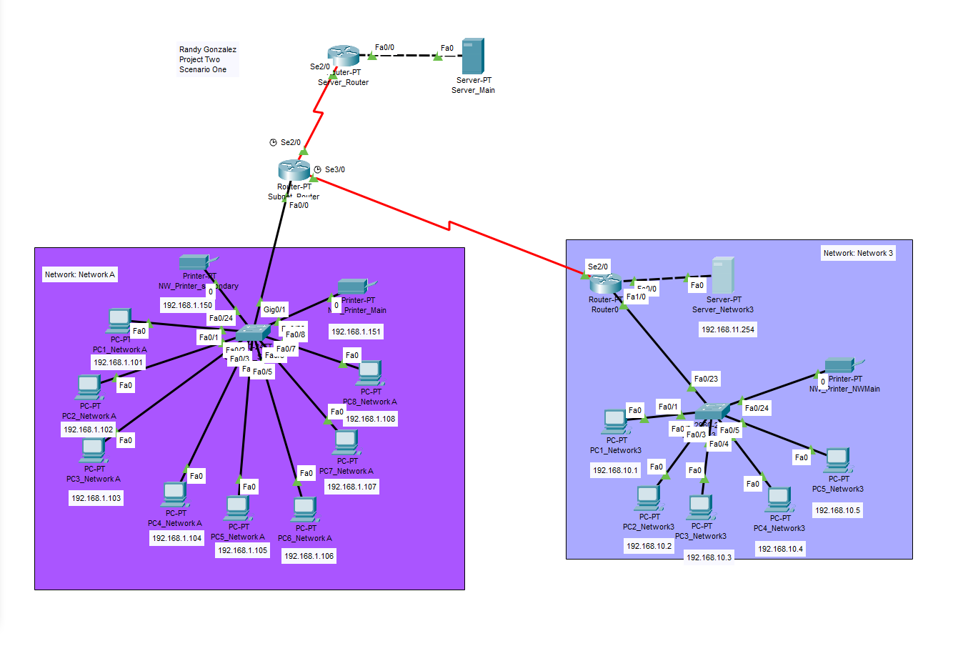

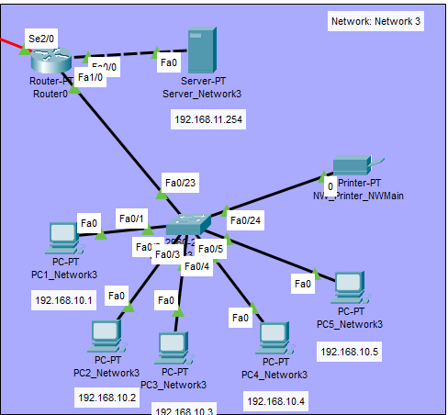

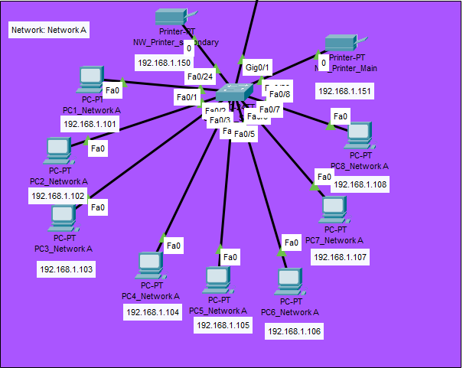

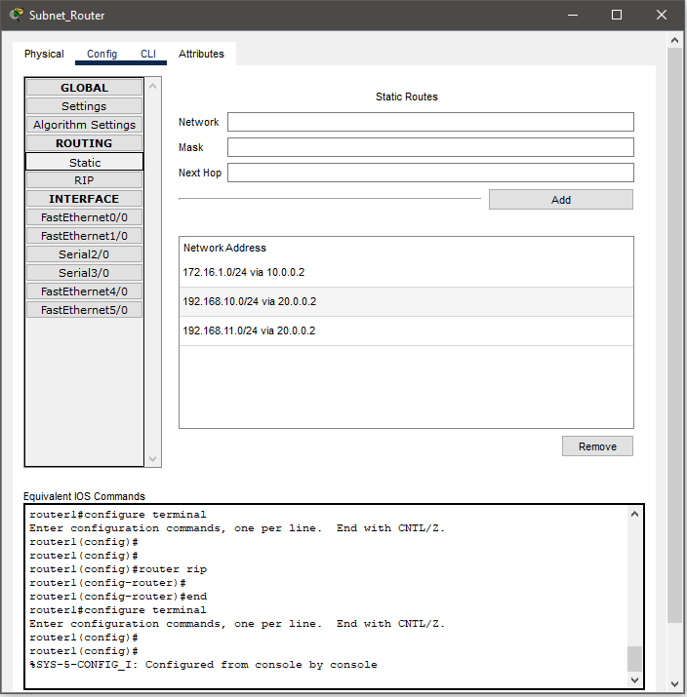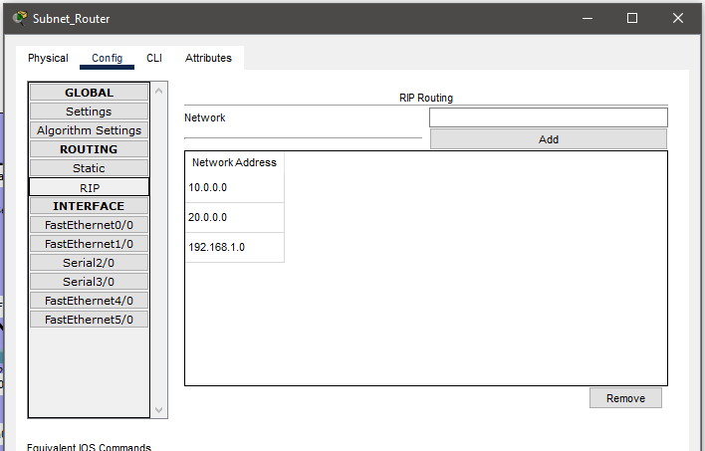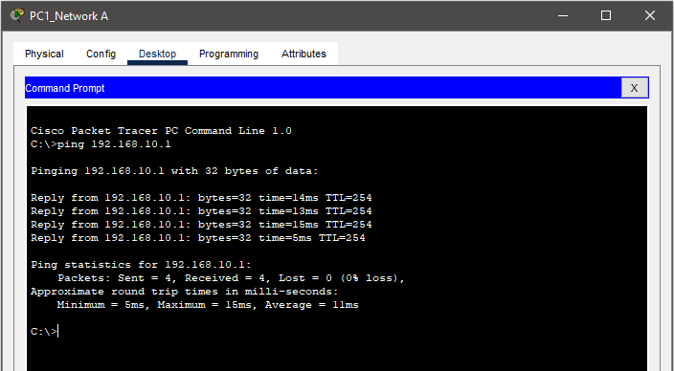

II. Network Design Rationale

1. IP networking

I used internet protocol (IP) to establish connections from Network A and Network 3. At first the network was divided into subnet 1, subnet 2, and Network 3. I began by combining subnets 1 and 2 into Network A provided with the IP 192.168.1.101 following every PC. I changed the IP address of network 3 to begin with 192.168.10.1 and so on because I added a router to separate this network.

1. Subnet masks

I used subnet masks by separating network A and network 3 using an existing switch and a new network router for network 3. Subnet masks are used to separate traffic within a larger network. I used this to combine the existing subnets 1 and 2 into one subnet to improve network traffic and security.

1. Network (DHCP) infrastructure

I did not use DHCP as I focused more on setting up RIP and static routing protocols.

1. Network address translation (NAT) protocol and port address translation (PAT) protocol

I used network address translation (NAT) protocol and port address translation (PAT) protocol to connect each computer to the new assigned networks. As you can see from the provided screen shot each pc is connected to the switches on both networks.